Lab 1: Number Storage Lab

1 Introduction

This lab extends the section Information Storage (chapter 2) in the textbook. It will immerse you in a problem context, which will require you to apply the theoretical concepts taught in the C language course. This will help you to develop basic skills needed to become a device level system developers and digital system designer. While going through this lab concentrate on developing a good understanding of the problem context, as it is a fundamental requirement for becoming a skilled system designer or application developer.

2 Type

This is an individual project.

3 Instructions

You are provided with the C program. This code (file name “lab1.c”) is available from the course materials.

Activities to do-
- Using less than 4 sentences, explain what function/action, the two statements marked with “Tag 1” and “Tag 2” perform.
Tag1 声明一个int类型的INT_VAL变量并给他一个地址，其地址是随机值
Tag2 将整形变量的占用字节数和位数输出
- Compile and run this program with “gcc” on the Linux machine.
root@AvA:/codeProject/CSAPP/Lab-1# ./lab1
This program was executed at time : 1953063456 secs
The sizes of different data type for this machine and compiler are -
int data type is 4 bytes or 32 bits long
double data type is 8 bytes or 64 bits long

c) When you ran your code, did you get the time executed to be negative? If yes, why did that happen? (Since time cannot be negative). How could you fix this? Figure out how to fix it and do the necessary modifications.
是的，因为在printf中把浮点数强制转换为了整数，他会把二进制位的01字符串解释为整数
This program was executed at time : -713031680 secs
The sizes of different data type for this machine and compiler are -
int data type is 4 bytes or 32 bits long
double data type is 8 bytes or 64 bits long

d) Change the data type of the variable time_stamp from double to long int. Is there a change in the values reported? If so, which of the values is the correct value? Why is there a difference?
第二个，因为printf解释整型的规律是一致的

e) Find out the structure of type “timeval”. Is it a standard C data type or is it platform specific?
No it is a platform specific。
Struct timeval
{
__time_t tv_sec;
__suseconds_t tv_usec;
};
该结构体是Linux系统中定义，struct timeval结构体在time.h中的定义为：
DESCRIPTION
The functions gettimeofday and settimeofday can get and set the time as
well as a timezone. The tv argument is a timeval struct, as specified
in <sys/time.h>:
struct timeval {
time_t tv_sec; /* seconds */
suseconds_t tv_usec; /* microseconds */
};

f) Print your output files for all runs in your report. (and the fixed versions if you made changes above ). Note: If you submit an output file with negative time, you must submit the corrected version also. Failure to do so will lead to loss of 50% of the points for this lab.
root@AvA:/codeProject/CSAPP/Lab-1# gcc lab1.c -o lab1
lab1.c: In function ‘main’:
lab1.c:32:3: warning: implicit declaration of function ‘exit’ [-Wimplicit-function-declaration]
32 | exit(1);
| ^~~~
lab1.c:32:3: warning: incompatible implicit declaration of built-in function ‘exit’
lab1.c:19:1: note: include ‘<stdlib.h>’ or provide a declaration of ‘exit’
18 | #include <sys/time.h> //For gettimeofday() function
+++ |+#include <stdlib.h>
19 |
lab1.c:46:48: warning: format ‘%ld’ expects argument of type ‘long int’, but argument 2 has type ‘long long int’ [-Wformat=]
46 | printf("This program was executed at time : %ld secs\n", time_stam
);
| ~~^ ~~~~~~~~~
| | |
| long int long long int
| %lld
root@AvA:/codeProject/CSAPP/Lab-1# ./lab
-bash: ./lab: No such file or directory
root@AvA:/codeProject/CSAPP/Lab-1# ./lab1
This program was executed at time : 1633938248 secs
The sizes of different data type for this machine and compiler are -
int data type is 4 bytes or 32 bits long
double data type is 8 bytes or 64 bits long
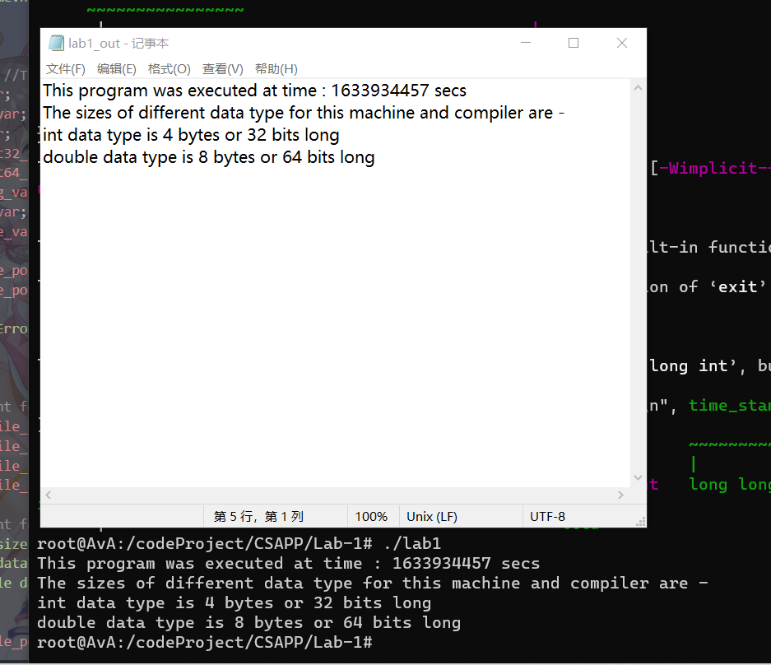

g) Write a C program to get bit and byte lengths for all the following C numerical data types according to the following table. The new C code file should have name “lab1_2.c” and it should generate an output file named “lab1_2_out.txt”. Hint – You can add codes to the lab1.c program to do this step.
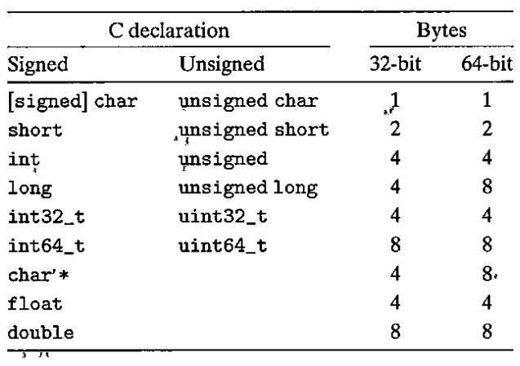
Figure 1 Typical sizes (in bytes) of basic C data types (from figure 2.3 in the textbook)

4 Handin
实验设备
实验结果

Results, Snapshots and Codes are inserted into Lab Report. You can hand in before the deadline.

